**Vocational Training Development Institute**

**Associate of Science Degree in Information, Communication and Technology**

**Enterprise Application Development CS244**

**Lecturer: Trevoir Williams**

**Prepared by**

**ID#:2012023854 Name: Lorenzo Williams**

**ID#:1400141183 Name: Omar Reid**

**ID#: 1600215150 Name: Loneil Stephens**

**ID#: 1817003309 Name: Kaycia Gordon**

**CONTENT**

**Acknowledgement**

For this project to be a success it would not be possible without the people would all play a role in it. It is at this point that we acknowledge our lecturer Mr Trevoir Williams, he is the one who gave us the knowledge and the inspiration we needed to have the belief that we could develop the Ember Medical Services desktop and web application. It was then that have acquired the knowledge and guidance that our group members came together to develop Ember Medical Services.

**Introduction**

Software solution is inevitable in contemporary businesses today to make business processes more efficient while solving problems. Ember Medical Service desktop and web application was creating to provide the solution for Ember Medical which is a very huge hospital situated in the corporate region. Over the years Ember Medical patients have grown to a huge amount hence records keeping of physical file has become tedious hence our team was drafted to develop an application that will provide a backend database which will store employees and patients records. This backend will be facilitated by a frontend user interface which will make it easy and user friendly when manipulating records. The implementation of the Ember Medical Service application will therefore be deployed. In the beginning of its deployment staff will make an effort to transfer physical records into the database. This will take a lot of data entry effort however records keeping at Ember Medical will gradually become digital data.

**Background of Project**

Ember Medical Service is design to make entering and storing records more easily and efficiently. The application solution was developed to provide both desktop and web application format. The IDE that was used for both instance of the application was Microsoft Visual Studio. The desktop application was writing in C Sharpe language using the Winform Application Framework while the web application form of the application was done using the Asp.Net Framework and also written with the C Sharp language.

**Operation Environment**

|  |  |
| --- | --- |
| Processor | Minimum 1 Ghz Processor |
| Operating System | Windows 10 |
| Memory | 4GB Ram or more |
| Hard Disk space | Minimum 100 GB For Database Usage |
| Database | Microsoft SQL Server 2019 |
| Internet Connectivity | MB or faster |
| Internet Browser | Google Chrome, Mozilla Firefox, Microsoft Edge |

**System Features & Requirements**

* This system will allow user to access their medical records, to print prescription and make medical enquiries
* FR1: All input is haptic interaction with screen elements. User will be required to authenticate and make selections from the screen. Users will also be able to communicate with a medical representative through instant messaging.
* FR2: The App will allow patients to have access their medical information (view medical history and results, schedule appointments, view and print prescriptions, etc) by logging into the portal with their reference number and password.
* FR3: Users will be able to view all available medical information on screen with the ability to print prescription on connected printer

**Entity Profile**

Located in the Kingston Corporate area Ember Medical has been around for over five years. Ember Medical began its operation as a medical complex June 2013. When it first started out it had a staff compliment of three, which included a doctor nurse and a receptionist. Since then Ember Medical has grown to now a staff compliment of over ten employees. The staff compliment now has specialized doctors hence a number of medical services are offered. The services offered include general checkup, dental checks and procedures, along with pharmaceutical solutions.

With the growth and expansion of Ember Medical there is also a growing population of its patient thus Ember Medical is the now the major provider of medical services within the corporate and wider areas such as rural Jamaica.

**Product Scope/ Problem Overview**

Ember Medical Services has been facing problems due to its paper/phone-based appointment system which is difficult to manage due to a large volume of patients. The purpose of this project is to resolve these problems by creating a web application to manage the appointment system. For the receptionist it makes easy to set date and time for the treatment of the patient to the relevant doctor. Doctor enters medical prescription and

**Functional Requirements**

**User Login**

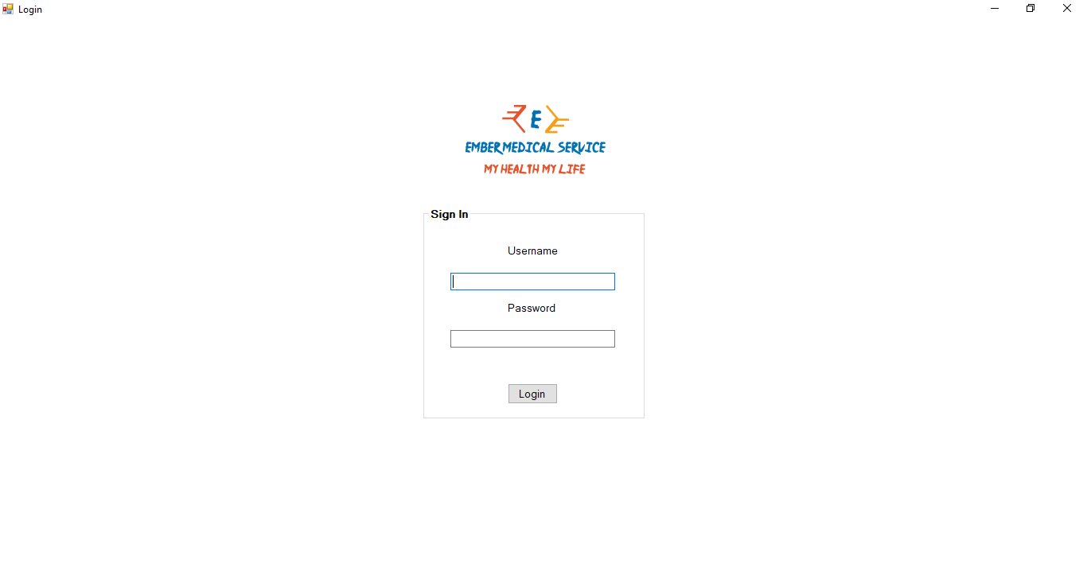

Upon opening the application user will be presented with this screen. Its function is solely to authenticate the user in order to gain access to the different functions of the system. If a user is unable to provide the correct information for username and password they will be denied access to the systems functions.

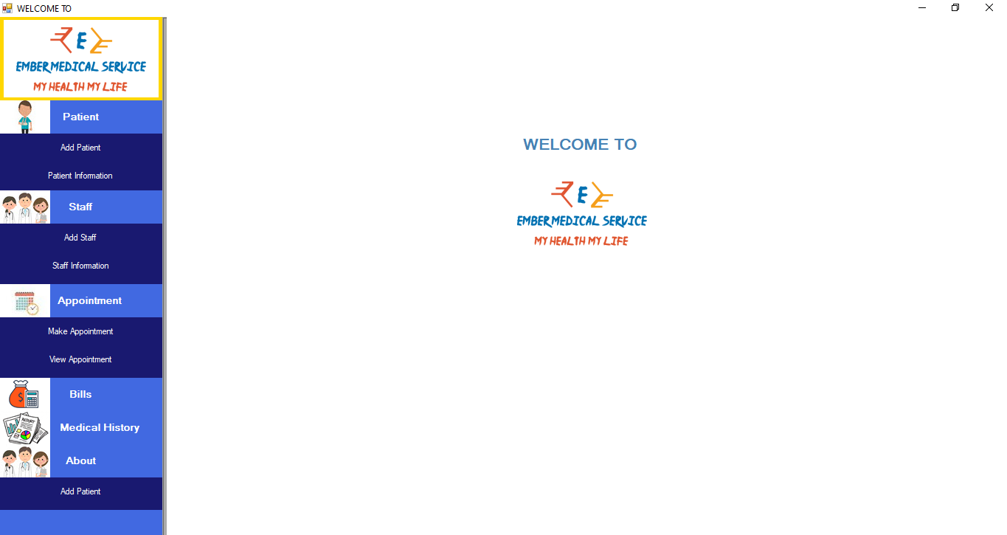Welcome and Main Menu

This screen follows a successful login. It creates an active user session. On the user right hand side there is a contemporary drop down menu pane. It provides clearly worded options which function as buttons. The user will select an option with a single leftt click of the mouse button.

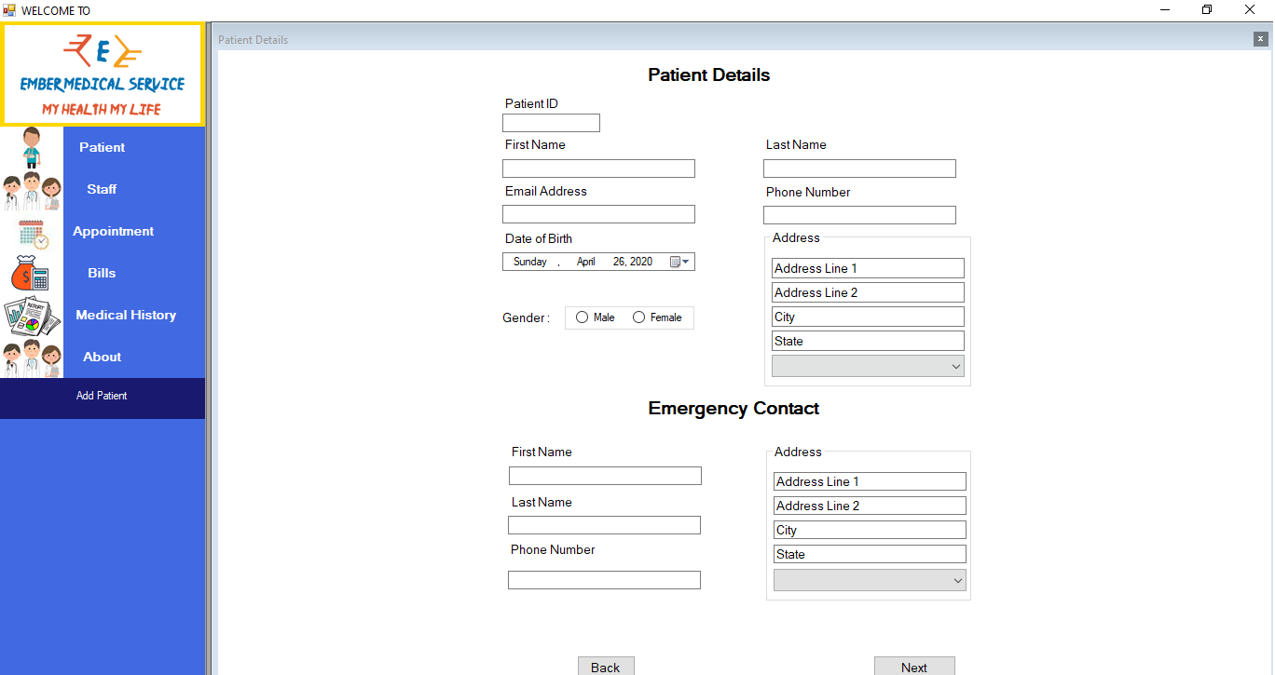Add New Patient

This form is presented after the user makes a single left click of the mouse. It provides textbox, drop down, list date picker and radio button that facilitates collection of patients’ data. For navigation purpose here is a back and next button which will provide you with additional form for data collection.

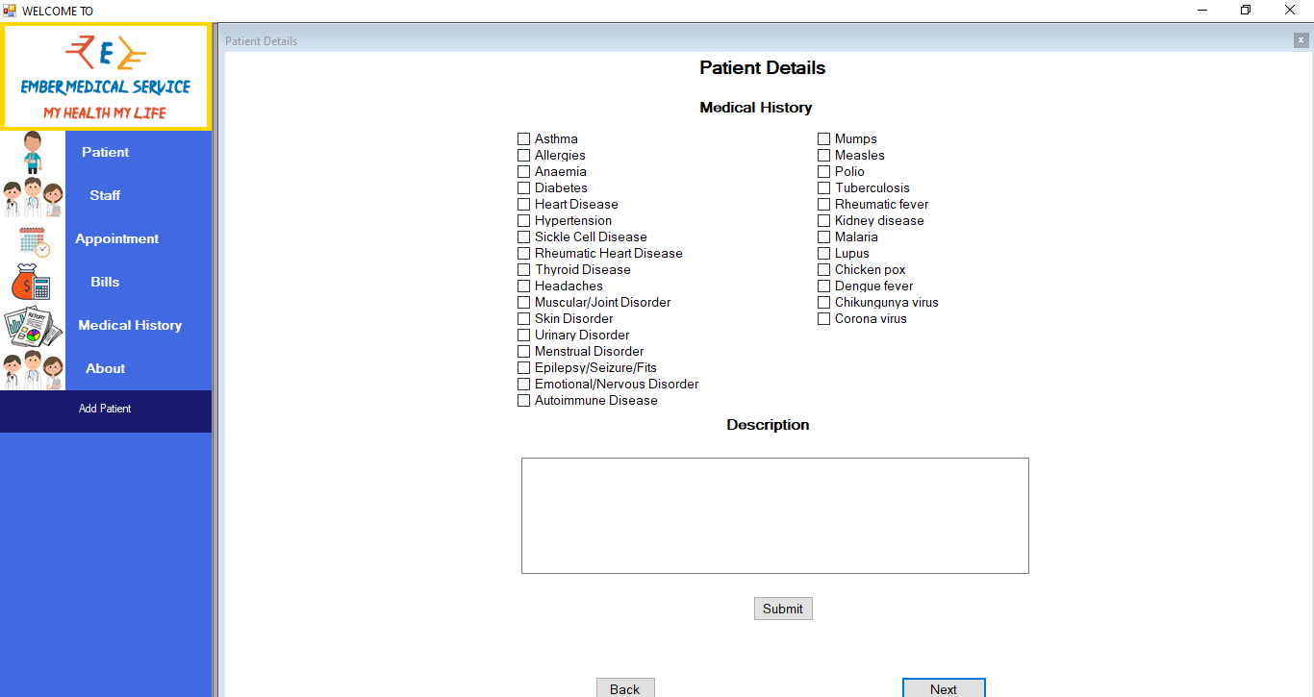Add Patients’ Medical History

This form is a continuation of data collection for a patient. It sole purpose is to capture data that indicates whether a patient has or had suffered anyone or more of the common medical conditions displayed. In addition the user is also provided with a description box that may be use optionally for additional data. Upon finishing user input the user must give the submit button a single left click to save data into the database.

Prompts User

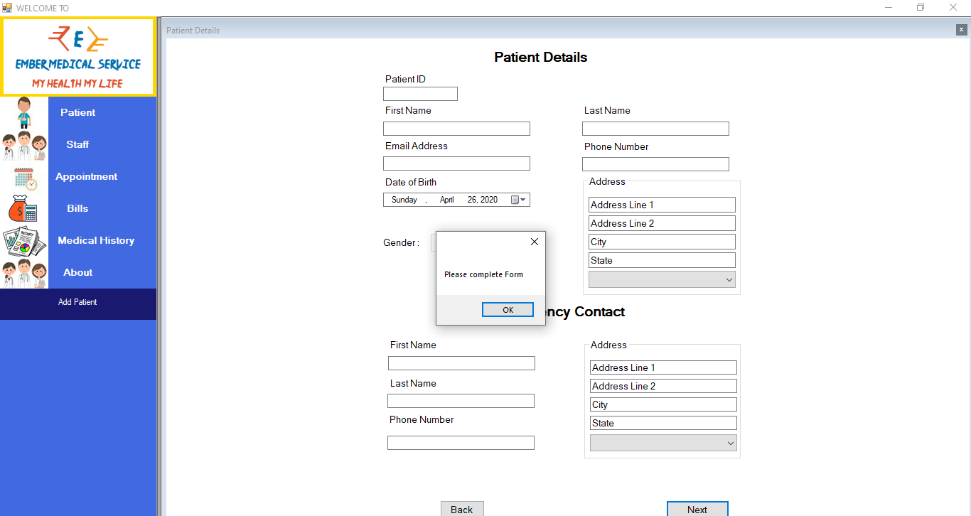

An important feature when designing an application is to ensure that data being saved into the database is clean and consistent hence the need for data validation checks. If the user does not complete the form correctly by inserting incorrect data type and leaving required data field empty the system will not proceed to save the day and will throw an error in this event. The user will be required to select OK from the message box displayed and then review their input before submitting.

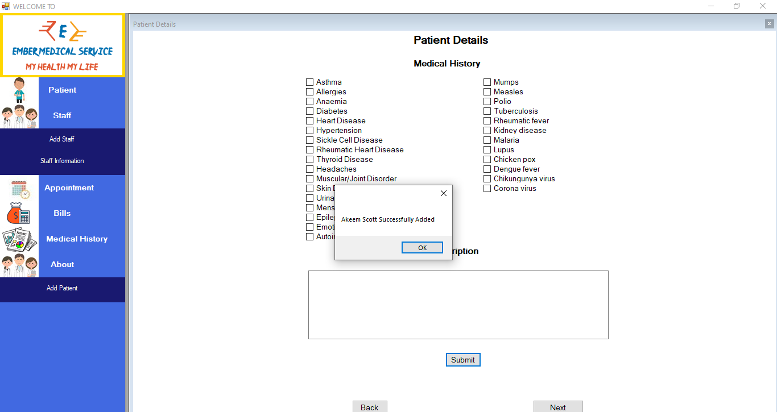Success Message

Once the system deems the data entered by the end user a valid a success message is displayed. This also serves as an indicator that the data has now been saved and a record has been created in the database.

Edit Patient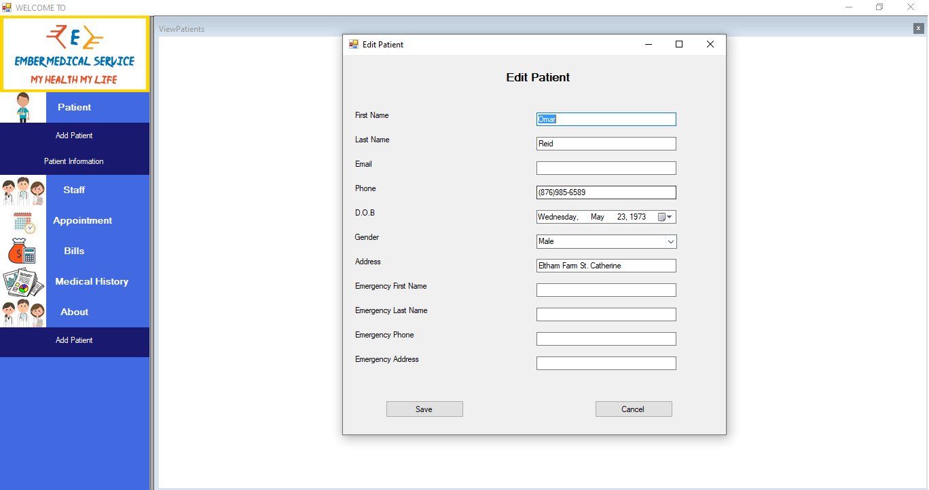

This screen allows the user to execute the update aspect of the CRUD. Data within a database should be able to be retrieved change/update in the system.

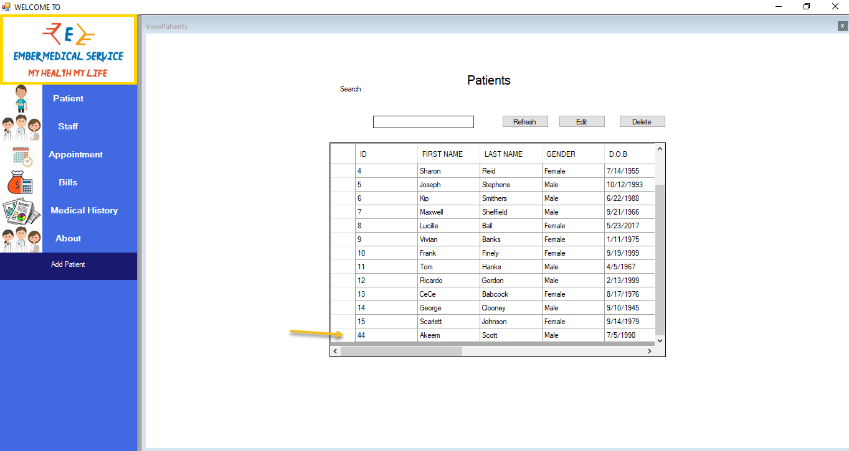Search Records

The user will be able to search the database thus it will verify that the record was stored properly in the database and will be able used for other CRUD feature in the future.